Art Dealer SRS Document
By
Group3
Joel Sandeep Bethi
Pavan Kalyan Yerramsetti
Raghu Varma Kankata
Reeshmitha Reddy Gaddam
Rishitha Musunuru
Subject: Software Engineering
Final Project

Contents
1.0 Introduction 3
1.1 Purpose 3
1.2 The Art Dealer Game Overview 3
1.3 Scope 4
1.4 Definitions, Acronyms, and Abbreviations 5
1.5 References 5
2.0 Process Model 6
2.1 Development Approach 6
2.2 Tools and Technologies 6
2.3 System Architecture Overview 7
2.4 Advantages of the Process Model 9
3.0 Use Cases 9
3.1 Overview 9
3.2 Use Case 1: Select Cards 9
3.3 Use Case 2: Choose a Pattern 10
3.4 Use Case 3: Evaluate Selection 10
3.5 Use Case 4: Submit Guess 11
3.6 Use Case 5: Restart Round 11
3.7 Use Case 6: View Feedback and Balloons Animation 11
3.8 Use Case Diagram (Summary) 12
4.0 UML Model 12
4.1 Overview 12
4.2 UML Modeling Objectives 13
4.4 Summary 18
5.0 Customer Journey Map 19
5.1 Overview 19
5.2 User Journey Stages 19
5.3 Teacher’s Journey 20
5.4 Emotional Curve 21
5.5 Key Insights 21
6.0 Personas 22
6.1 Overview 22
6.2 Persona 1: Early Learner (Grades K–2) 22
6.3 Persona 2: Intermediate Learner (Grades 3–5) 22
6.4 Persona 3: Advanced Learner (Grades 6–8) 23
6.5 Persona 4: Teacher Facilitator 24
7.0 User Interface Mock-Up 24
8.0 Testing Strategy 28
8.1 Unit Testing 28
8.2 Integration Testing 28
8.3 Usability Testing 28
8.4 Validation Testing 29
8.5 Future Enhancements for Testing 29
9.0 Conclusion 29

1.0 Introduction

1.1 Purpose
The purpose of The Art Dealer Game is to create an engaging, educational simulation that supports K–8 students in learning computational thinking, mathematics, and logical reasoning through an interactive and visually stimulating card-based game. The software acts as both an instructional tool and an entertainment platform, designed to stimulate curiosity, encourage hypothesis testing, and enhance students’ ability to identify and generalize patterns.
The main objectives of this project include:
- Encouraging pattern recognition and data interpretation through visual and numerical reasoning.
- Supporting collaborative learning, allowing two students to play together and share ideas.
- Providing incremental complexity, ensuring smooth cognitive progression as students advance through grade levels.
- Delivering instant feedback and engagement, using audio-visual cues such as color changes, success sounds, and animations.
This project was developed as part of the Software Engineering (Fall 2025) course at Lewis University. It demonstrates core software design principles, requirement specification, modular programming, and user-centered interface design.

1.2 The Art Dealer Game Overview
The Art Dealer Game is a desktop-based educational application developed in Python using the Pygame library. The gameplay revolves around the concept of discovering hidden “buying patterns” of an art dealer represented through playing cards. Students, acting as art sellers, must determine which cards the dealer prefers by analyzing results from their card selections.
The game consists of three main modes, aligned with grade-level complexity:
- K–2 Level (Beginner Mode): Focuses on color and suit recognition patterns (e.g., “all red,” “all hearts,” “all black”).
- 3–5 Level (Intermediate Mode): Introduces arithmetic and logical concepts (e.g., “sum to 9,” “all primes,” “ace and a black jack”).
- 6–8 Level (Advanced Mode): Expands on prior knowledge with complex logic and probability-based combinations (e.g., “sum to 21,” “all face cards of same color”).
Each level maintains a consistent user interface to ensure familiarity while progressively challenging students with higher-level cognitive reasoning tasks. The simulation incorporates visual feedback (e.g., card highlighting, balloons) and auditory reinforcement (sound effects and music) to keep players motivated.
The system is designed for use by:
- Students: Primary users who engage with the game directly.
- Teachers: Facilitators who can guide gameplay and evaluate student learning outcomes.

1.3 Scope
The Art Dealer Game provides a visual and logical simulation tool to teach young learners about pattern recognition and computational reasoning. The software functions as an interactive learning environment rather than a traditional scoring game.
In-Scope Features:
- Display of 12 random cards per round.
- Selection of exactly 4 cards by the player.
- Validation of card selection against pre-defined mathematical or logical patterns.
- Pattern selection via dropdown menu.
- Audio cues for actions and results.
- Visual animations (e.g., balloons) for correct solutions.
- Progressive levels corresponding to school grades.
Out-of-Scope Features:
- Online multiplayer or networked gameplay.
- Persistent scoring or student tracking.
- Complex machine learning-driven pattern generation.

1.4 Definitions, Acronyms, and Abbreviations
Term | Definition
Dealer | The computer-controlled entity selecting a hidden card pattern for each round.
Seller | The student or player attempting to discover the dealer’s pattern.
Pattern | The logical or mathematical rule defining which cards the dealer “buys.”
Market | The 12 cards visible to the player each round.
Guess | The player’s proposed rule describing what the dealer buys.
Evaluation | The process of testing whether selected cards meet the chosen pattern.
Round | A single gameplay cycle ending when the dealer’s pattern is discovered or revealed.

1.5 References
- IEEE Std 830-1998 – Recommended Practice for Software Requirements Specifications.
- Lewis University Course Syllabus (Fall 2025) – Software Engineering Requirements.
- Pygame Documentation: https://www.pygame.org/docs/
- Python Documentation: https://docs.python.org/3/
- Educational references on gamified learning and computational thinking for K–8 students.

2.0 Process Model

2.1 Development Approach
The development of The Art Dealer Game followed the Iterative and Incremental Development Model, which combines the strengths of both the Waterfall and Agile methodologies. This approach was selected to allow continuous refinement of requirements and frequent testing cycles while ensuring a structured and traceable process suitable for academic software projects.
Each iteration focused on developing and validating a specific layer of functionality — from basic card rendering to full game logic and finally the user interface and animations. This ensured early detection of design issues and improved the quality of the final product.
Key Phases of Development
- Requirement Analysis: Identified educational goals, target users, and software constraints. Defined game logic (dealer, cards, patterns) and interface needs.
- System Design: Created architectural layout for the game engine, UI components, and audio subsystems.
- Implementation: Developed modular Python scripts (main.py, game_engine.py, and ui_manager.py) to separate logic, presentation, and user interaction.
- Testing & Feedback: Conducted playtesting for each grade level to ensure clarity and balanced difficulty.
- Refinement & Finalization: Integrated visual polish (buttons, balloons, audio cues) and validated all possible user scenarios.

2.2 Tools and Technologies
The Art Dealer Game leverages lightweight, open-source technologies to ensure accessibility, ease of deployment, and minimal hardware requirements.
Category | Tool / Technology | Description
Programming Language | Python 3.12+ | Core language for development. Chosen for its readability and educational suitability.
Graphics & Game Engine | Pygame 2.6+ | Provides rendering, event handling, sound playback, and animation capabilities.
IDE | Visual Studio Code / PyCharm | Used for development, debugging, and version control integration.
Version Control | Git / GitHub | For version tracking, collaboration, and backup of project files.
Media Assets | Custom PNG images & WAV/MP3 files | Used for cards, sound effects, and background visuals.
Operating Systems | Windows, macOS, Linux | Cross-platform compatibility achieved via Pygame.

2.3 System Architecture Overview
The system follows a modular layered architecture, where each module is responsible for a distinct part of the game logic and user experience.
Architectural Layers:
- Presentation Layer (UI Manager): Handles all graphical rendering (cards, buttons, dropdowns) and user inputs. It includes:
  - Button management with hover/click states.
  - CardView rendering for visualizing card data.
  - AudioBank for sound effects and music playback.
- Game Logic Layer (Game Engine): Manages the internal rules, card deck generation, and pattern logic. It provides:
  - Pattern evaluation functions (e.g., all hearts, sum to 9).
  - GameSession class that tracks market cards, dealer’s hidden pattern, and evaluation outcomes.
- Controller Layer (Main Script): Acts as the orchestrator, connecting the UI and logic layers. It manages the scenes:
  - scene_menu(): Handles the level selection menu.
  - scene_game(): Runs the main gameplay loop, evaluating user inputs and providing feedback.
Data Flow Summary:
- The Game Engine initializes the deck and generates a hidden pattern.
- The UI Layer displays the available cards and pattern options.
- The User Input (selected cards and pattern guess) is processed through event handlers.
- The Evaluation Module checks if the selected cards match the guessed pattern and provides instant feedback.
- The Result Feedback is shown visually (green borders, balloons) and aurally (success sound).
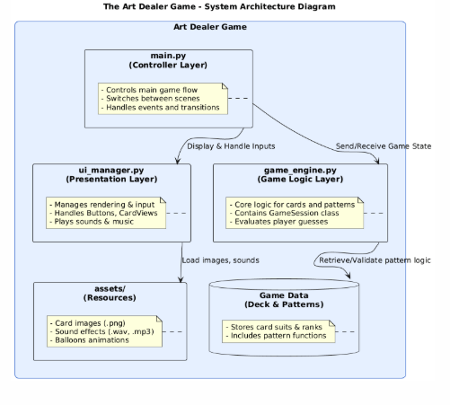

2.4 Advantages of the Process Model
- Flexibility: Easy to incorporate new patterns and UI features through modular design.
- Iterative Improvement: Each round of testing allowed the refinement of difficulty balance and pattern accuracy.
- User-Centric Design: Frequent feedback from test users (students) guided UI placement and interaction flow.
- Educational Suitability: Aligns with academic learning cycles and promotes hands-on experimentation.

3.0 Use Cases

3.1 Overview
Use cases describe the main interactions between the user (student or teacher) and the Art Dealer Game system. Each use case outlines the actors, preconditions, flow of events, and postconditions that guide gameplay and functionality. The system supports multiple levels of educational complexity, with consistent interaction mechanics across all modes.
Actors:
- Player (Student): The main user who interacts with the game, selects cards, chooses patterns, and submits guesses.
- Dealer (System): The automated agent that secretly holds a pattern and validates the player’s guesses.
- Teacher (Facilitator): Observes and assists the student, providing learning guidance.

3.2 Use Case 1: Select Cards
Actor: Player
Goal: To select exactly four cards from the visible market to test against a pattern.
Preconditions: A set of 12 cards is displayed on the screen.
Main Flow:
- The player clicks on cards one by one.
- The system highlights selected cards with a yellow border.
- The system restricts selection to a maximum of four cards.
- If more than four are selected, a warning message appears (“Please select 4 cards”).
Postconditions: The four selected cards remain highlighted until evaluated or reset.

3.3 Use Case 2: Choose a Pattern
Actor: Player
Goal: To select a logical or mathematical pattern that may match the dealer’s hidden rule.
Preconditions: A dropdown list of available patterns is visible.
Main Flow:
- The player clicks the dropdown menu to reveal pattern options.
- The system displays pattern names (e.g., “All Red”, “Sum to 9”, “All Hearts”).
- The player selects one pattern.
- The selected pattern is displayed on the button (“Pending: [Pattern Name]”)
Postconditions: The selected pattern is stored as the player’s active guess for evaluation.

3.4 Use Case 3: Evaluate Selection
Actor: Player
Goal: To verify whether the four selected cards match the chosen pattern.
Preconditions: Four cards and one pattern have been selected.
Main Flow:
- The player clicks the “EVALUATE” button.
- The system checks whether the selected cards match the pattern.
- If matched, the cards are highlighted in green and a success message appears.
- If mismatched, an error message appears (“Pattern not matched”).
- A sound effect plays for feedback.
Postconditions: Evaluation results are displayed; the system waits for the player’s next action.

3.5 Use Case 4: Submit Guess
Actor: Player
Goal: To submit the selected pattern as a final guess against the dealer’s hidden pattern.
Preconditions: The player has evaluated cards successfully at least once.
Main Flow:
- The player clicks “SUBMIT GUESS.”
- The system compares the player’s selected pattern with the dealer’s hidden pattern.
- If the guess is correct, the system displays balloons, plays a success sound, and restarts the round.
- If incorrect, a warning message appears (“Dealer’s pattern differs”).
- The player has a limited number of attempts (three).
Postconditions: If maximum guesses are reached, the dealer’s pattern is revealed before restarting the round.

3.6 Use Case 5: Restart Round
Actor: Player
Goal: To reset the current round and begin a new one with fresh cards and a new pattern.
Preconditions: A game round has been completed or maximum guesses have been used.
Main Flow:
- The player clicks “RESTART.”
- The system reshuffles the deck and generates a new market of 12 cards.
- The dealer selects a new hidden pattern.
- The game interface resets card highlights and messages.
Postconditions: The player begins a new round.

3.7 Use Case 6: View Feedback and Balloons Animation
Actor: Player
Goal: To receive visual and auditory feedback based on game outcomes.
Preconditions: A pattern evaluation or final guess has been completed.
Main Flow:
- When the player correctly matches the dealer’s pattern, the system displays balloons rising across the screen.
- A success sound effect plays.
- When the player fails, a short warning message appears with a red highlight.
- The system automatically resets after a delay.
Postconditions: Feedback is displayed, and the player can continue the next round.

3.8 Use Case Diagram (Summary)
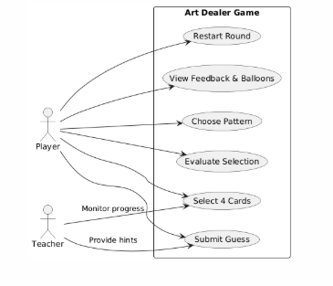

4.0 UML Model

4.1 Overview
The Unified Modeling Language (UML) is used to provide a standardized visual representation of the structure, behavior, and interaction of system components within The Art Dealer Game. UML diagrams help describe both the static architecture and dynamic flow of gameplay logic, facilitating better understanding for designers, developers, and educators.
The system is developed using Python and Pygame, employing a modular approach where each file (main.py, game_engine.py, ui_manager.py) has distinct responsibilities. The UML models highlight how the different components work together to support gameplay, visual feedback, and educational learning outcomes.
The following diagrams are presented:
- Use Case Diagram – Represents key user interactions and goals.
- Class Diagram – Illustrates core classes, their attributes, and relationships.
- State Diagram – Shows transitions between different states in the game loop.
- Activity Diagram – Explains the logical flow of events in gameplay.
- Deployment Diagram – Displays the physical setup and components of the system.

4.2 UML Modeling Objectives
The main objectives of using UML in this project are:
- Clarity in System Design: UML helps translate conceptual design into technical structure.
- Enhanced Communication: Facilitates collaboration among team members and stakeholders.
- Maintainability: Provides documentation that aids in debugging, extension, and scaling of the system.
- Verification and Validation: Helps ensure system functionality aligns with user requirements.
4.3 UML Diagram Explanations
4.3.1 Use Case Diagram
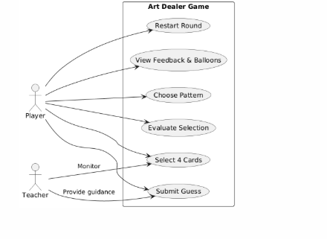
The Use Case Diagram captures how different actors interact with the game. The main actors are:
- Player (Student): Plays the game, selects cards, and guesses patterns.
- Teacher: Observes and supports gameplay for educational outcomes.
- System (Dealer): Holds the hidden pattern and evaluates user actions.
This diagram shows functional relationships between the user and the system, defining the core goals such as selecting cards, choosing patterns, evaluating, submitting guesses, and restarting the game.
4.3.2 Class Diagram
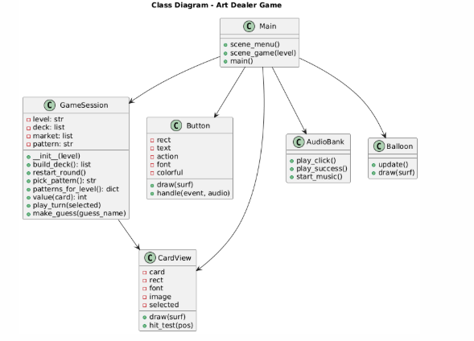
The Class Diagram represents the static structure of the software. It identifies major classes, their attributes, and how they relate to one another.
Key components:
- GameSession: Handles game logic, pattern selection, and evaluation.
- Button: Manages all interactive buttons and UI actions.
- CardView: Displays and manages card visuals and states.
- AudioBank: Manages sound effects and background music.
- Balloon: Controls success animations.
- Main: Connects all modules to manage the flow of scenes and gameplay.
Relationships:
- The Main class depends on GameSession, Button, and CardView for user interactions.
- The GameSession interacts with cards and defines the logic for pattern matching.
- The AudioBank and Balloon classes handle user feedback (audio and animation).
4.3.3 State Diagram
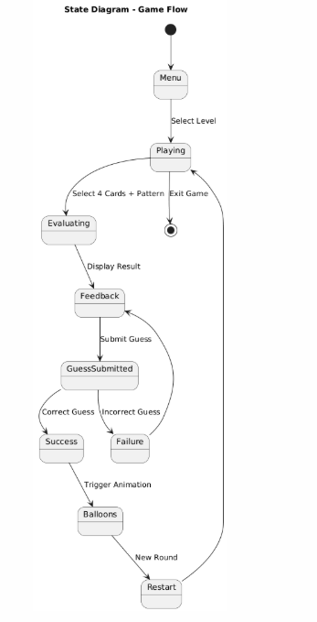
The State Diagram describes the different states that the system goes through during gameplay and how transitions occur between them. It focuses on how the game responds to user actions.
Key states:
- Menu: The initial screen where players select the game level.
- Playing: Cards are displayed; players select and guess.
- Evaluating: The system checks card patterns.
- Feedback: Messages or animations show results.
- Restart: The game resets for a new round.
- Exit: Player quits the game.
This diagram highlights the event-driven nature of the game and the transitions triggered by player interactions.
4.3.4 Activity Diagram
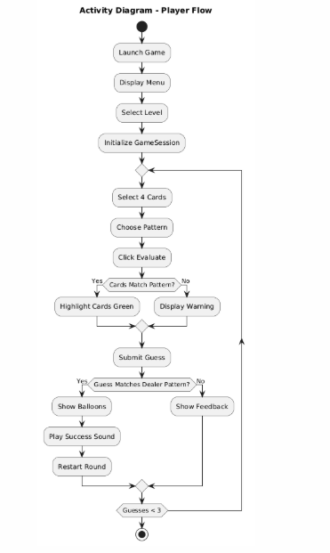
The Activity Diagram visualizes the workflow of gameplay. It follows a sequence of activities from launching the game to completing a round.
It details decisions, conditions, and repeated loops such as selecting cards, evaluating, submitting guesses, and restarting.
It represents:
- User actions: Selection, evaluation, and submission.
- System responses: Validation, feedback, and progression.
- Control flow: The repetition of actions until a success or failure condition is reached.
4.3.5 Deployment Diagram
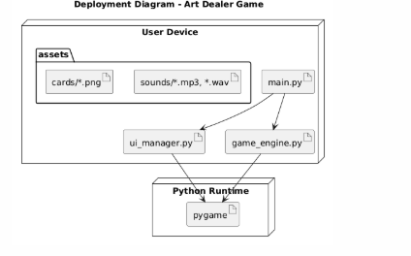
The Deployment Diagram explains how the system’s components are deployed in a runtime environment. It shows the hardware and software structure that supports the game.
Deployment elements include:
- User Device: Hosts the application, typically a computer or laptop.
- Python Environment: Executes the source code and runs the Pygame engine.
- Assets Folder: Contains all multimedia elements like images and sounds.
- Pygame Library: Provides rendering, event handling, and audio capabilities.
This diagram emphasizes that the Art Dealer Game is self-contained and can run independently on any system with Python and Pygame installed.

4.4 Summary
Together, these UML diagrams describe how the system is structured, how it behaves dynamically, and how it operates within its environment.
They provide a full architectural view that supports future maintenance, scalability, and integration with potential extensions such as multiplayer mode or AI-based adaptive difficulty.

5.0 Customer Journey Map

5.1 Overview
The Customer Journey Map illustrates the experience of users — students and teachers — as they engage with The Art Dealer Game. It identifies key stages, touchpoints, motivations, challenges, and emotional responses during gameplay and learning. Since the application is designed for K–8 students, the journey emphasizes simplicity, curiosity, and fun, while enabling progressive exposure to computational thinking and math reasoning.

5.2 User Journey Stages
Stage | User Actions | System Responses | User Emotions | Opportunities for Improvement
1. Entry / Launch | Student or teacher launches the game from the computer. | Game opens with colorful menu, cheerful music, and level options (K–2, 3–5, 6–8). | Excitement, curiosity. | Add character intro voiceover to make it friendlier.
2. Level Selection | User selects grade level. | System adjusts pattern complexity automatically. | Anticipation of challenge. | Display sample examples of each level before starting.
3. Gameplay Start | Player views 12 cards and selects 4. | System highlights selected cards and restricts to 4 selections. | Engagement, focus. | Add visual hints for younger players.
4. Pattern Guessing | Player selects a pattern from dropdown and clicks “EVALUATE.” | System checks cards and provides success/failure feedback with animations. | Confidence or mild disappointment. | Include encouraging messages for wrong attempts.
5. Submitting Guess | Player submits pattern guess. | If correct, balloons rise and success sound plays; if not, warning shown. | Joy, satisfaction, or determination. | Provide subtle clue system after multiple failures.
6. Feedback and Restart | Player restarts or returns to main menu. | Game resets with new pattern and fresh deck. | Motivation to try again. | Add tracking to record learning progress.

5.3 Teacher’s Journey
Teachers interact indirectly with the system, often as facilitators or observers. Their focus is on student learning outcomes and engagement rather than winning the game.
Stage | Teacher Role | Goal | System Support
Setup | Launch game and assist students with level selection. | Ensure students understand interface. | Clear instructions and large visual cues.
Observation | Monitor students’ selection and reasoning. | Identify computational thinking processes. | Real-time visual cues and feedback messages.
Discussion | Debrief game results with students. | Connect patterns to math and logic. | Clear textual feedback from system.
Reflection | Plan next session. | Measure student progress. | Optional logs or success summaries (future enhancement).

5.4 Emotional Curve
The emotional curve across the journey is intentionally designed to maintain engagement:
- Excitement at start (color, music, animations).
- Challenge and curiosity during selection and guessing.
- Joy and accomplishment after success.
- Encouragement after failure, promoting retry and learning resilience.

5.5 Key Insights
- Dual-User Design: The system caters to both students and teachers.
- Learning Through Play: Gameplay reinforces logic, pattern recognition, and collaboration.
- Emotion-Driven Retention: Visual rewards and positive reinforcement sustain motivation.
- Simplicity: Minimal text, intuitive visuals, and limited choices prevent cognitive overload for younger users.

6.0 Personas

6.1 Overview
Personas represent target user groups for The Art Dealer Game. They help in understanding the user’s needs, goals, and behaviors to guide design and functionality.
This section defines three key personas based on age and role: Early Learner, Intermediate Learner, and Teacher Facilitator.

6.2 Persona 1: Early Learner (Grades K–2)
- Name: Lily
- Age: 6
- Role: Student / Player
- Tech Comfort: Low to Medium — familiar with tablet and keyboard basics.
- Goals:
  - Learn color and shape patterns.
  - Experience success through visual cues and sounds.
- Frustrations:
  - Too much text or complicated instructions.
  - Overly difficult pattern challenges.
- Motivators:
  - Bright visuals, balloons, cheerful feedback sounds.
- Scenario:
Lily plays the game with a partner. They choose “All Red” and laugh when balloons appear after guessing correctly. She learns color-based categorization while having fun.

6.3 Persona 2: Intermediate Learner (Grades 3–5)
- Name: Ethan
- Age: 9
- Role: Student / Player
- Tech Comfort: Medium — comfortable with mouse, dropdowns, and math basics.
- Goals:
  - Understand mathematical relationships (sums, parity, and primes).
  - Develop pattern recognition and logical reasoning.
- Frustrations:
  - Abstract logic without immediate feedback.
  - Too few hints for challenging levels.
- Motivators:
  - Sense of achievement, competing with a partner.
- Scenario:
Ethan plays the “Sum to 9” challenge, experimenting with card combinations to match numbers. Each correct evaluation gives him visual confidence in number-based reasoning.

6.4 Persona 3: Advanced Learner (Grades 6–8)
- Name: Aisha
- Age: 13
- Role: Student / Player
- Tech Comfort: High — confident with mouse and keyboard.
- Goals:
  - Work with complex logic and probability patterns.
  - Compete against peers or act as the “dealer.”
- Frustrations:
  - Lack of advanced challenges after mastering simpler ones.
- Motivators:
  - Competitive gameplay and dynamic difficulty.
- Scenario:
Aisha plays the dealer role in the “Two Player Mode.” She selects a secret pattern for her partner to guess, learning logic-building and fairness through gameplay.

6.5 Persona 4: Teacher Facilitator
- Name: Mr. Brown
- Age: 35
- Role: Educator / Facilitator
- Tech Comfort: High — experienced with educational tools.
- Goals:
  - Observe students’ logical reasoning.
  - Use gameplay results for formative assessment.
- Frustrations:
  - Limited analytics or tracking features.
- Motivators:
  - Engaged classroom environment.
- Scenario:
Mr. Brown sets up the game for pairs of students. He notes how they discuss their choices and asks guiding questions like “Why did you pick those cards?”, fostering critical thinking.

7.0 User Interface Mock-Up
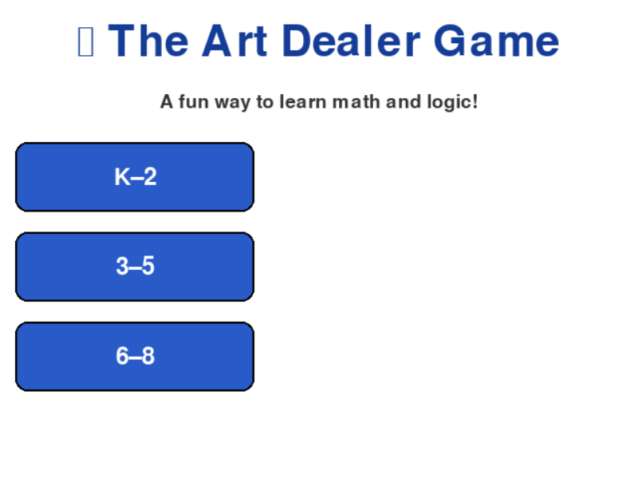
The Art Dealer Game interface is designed to be colorful, engaging, and child-friendly while maintaining consistency across all grade levels (K–8).
The layout uses large, easy-to-click buttons and clear visuals that minimize text-based instructions, supporting both early learners and older students.
The primary user interface elements include:
- Main Menu Screen: Displays the game title “The Art Dealer Game”, background music, and three large buttons — “K–2,” “3–5,” and “6–8” — aligned vertically on the left side.
- Game Screen: Contains the following key components:
  - Title Bar: Displays the current level (e.g., “Art Dealer Game (3–5)”) and a short subtitle with instructions.
  - Card Grid Area: Shows a 3×4 grid of 12 cards in the center of the screen. Cards can be clicked to select or deselect, with a bright yellow border highlighting selections.
  - Left-Side Control Panel: Includes the primary control buttons arranged vertically:
    - “EVALUATE”
    - “RESTART”
    - “BACK”
    - “SELECT PATTERN” (dropdown for pattern selection)
    - “SUBMIT GUESS”
  - Exit Button: Located at the bottom right to close the game easily.
  - Warning/Feedback Zone: Displays short messages such as “Please select 4 cards” or “Pattern matched!” at the bottom center.
  - Balloon Animation Zone: Balloons rise from the bottom after success, reinforcing positive feedback visually.
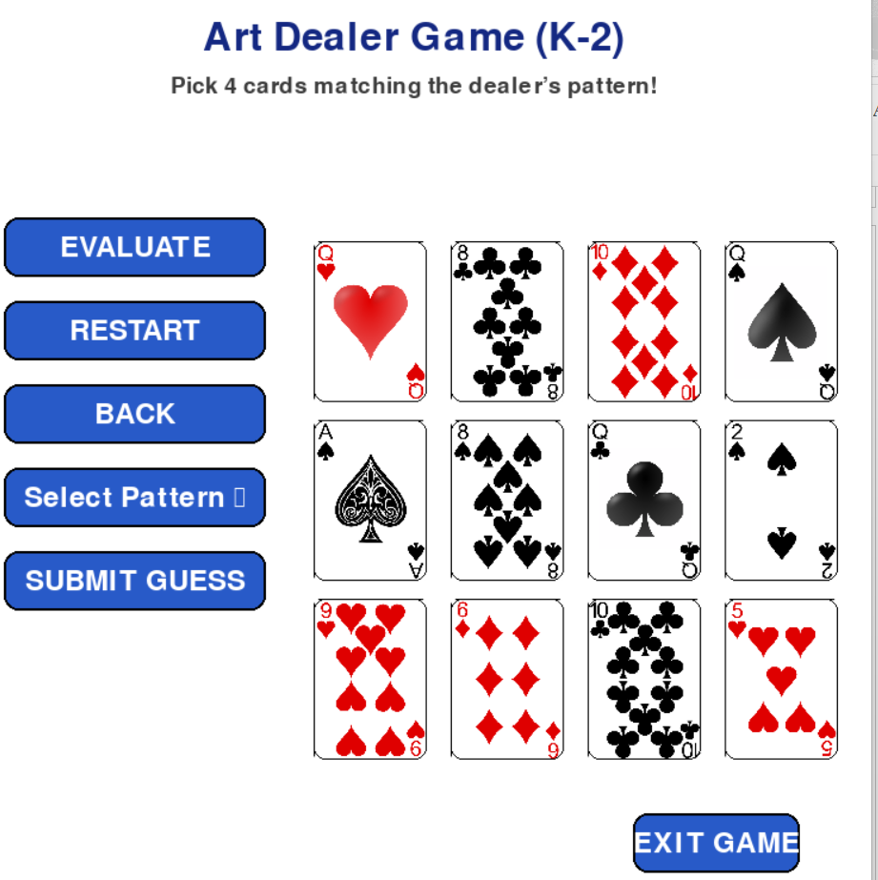
Design Principles
- Simplicity:
Interface uses limited text, large fonts, and recognizable icons to aid comprehension for younger students.
- Consistency:
The color scheme and layout remain uniform across all grade levels, minimizing the learning curve.
- Accessibility:
Contrasting colors, clear icons, and minimal mouse movement improve usability.
- Feedback Orientation:
Immediate audio-visual responses (click sounds, color change, balloons) maintain engagement.
Visual Style
The aesthetic combines blue and white tones for calmness, with accent colors (yellow for selections, red for warnings, green for success).
Animations are soft and short to avoid overstimulation, ensuring focus remains on learning and problem-solving.

8.0 Testing Strategy
Testing ensures that The Art Dealer Game performs reliably, remains user-friendly, and supports educational objectives. The testing strategy focuses on verifying correct logic execution, visual feedback, and cross-platform stability.

8.1 Unit Testing
Unit tests target core modules individually:
- game_engine.py: Validates deck creation, randomization, and pattern logic (e.g., “sum to 9,” “all red”).
- ui_manager.py: Ensures card selection, button response, and image loading work correctly.
- main.py: Verifies transitions between menu and game scenes.
Each function is tested with representative input sets to confirm predictable and accurate outcomes.

8.2 Integration Testing
Integration testing ensures seamless interaction between modules:
- Confirm that Button actions trigger expected game logic.
- Check that GameSession responses update CardView visuals properly.
- Verify that pattern selection and evaluation synchronize with the displayed feedback.
The main test scenario involves simulating a complete round: select cards → choose pattern → evaluate → submit guess → restart.

8.3 Usability Testing
Given the target audience (K–8), usability testing focuses on simplicity and engagement:
- Observe pairs of students playing each level to identify confusion points.
- Ensure instructions are intuitive without requiring teacher intervention.
- Evaluate accessibility features such as button size, visual clarity, and sound levels.
Teacher feedback is used to refine the interface for clarity and instructional value.

8.4 Validation Testing
Validation testing ensures the system meets learning objectives and user expectations:
- Correctness: The dealer’s pattern and evaluation results must align.
- Feedback Timing: Balloons and sound must trigger within one second of a win.
- Error Handling: Messages should appear for invalid actions (e.g., selecting fewer than 4 cards).
- Game Flow: Transitions (menu → game → restart) must operate without lag or crash.

8.5 Future Enhancements for Testing
Planned improvements include:
- Automated regression tests for future updates.
- Log-based analytics to measure student performance trends.
- AI-based hint systems tested via A/B experiments.

9.0 Conclusion
The Art Dealer Game project successfully combines educational principles with interactive gameplay to create a meaningful learning experience for K–8 students. Through the use of colors, numbers, and logic-based patterns, the system transforms abstract computational thinking into engaging visual problem-solving tasks.
This Software Requirements Specification (SRS) has outlined the system’s purpose, design, process model, user interactions, and validation strategies. It demonstrates how the modular architecture integrating main.py, ui_manager.py, and game_engine.py — ensures scalability, clarity, and maintainability. The inclusion of UML models and testing strategies guarantees structural soundness and functional reliability across various user levels.
By emphasizing playful learning, accessibility, and positive feedback, the Art Dealer Game bridges the gap between entertainment and education. It empowers teachers to observe logical reasoning in action while motivating students to explore, hypothesize, and validate their choices in a safe digital environment.
In the future, this framework can be expanded to include:
- Adaptive difficulty levels driven by AI.
- Collaborative multiplayer modes for peer learning.
- Data analytics to measure student engagement and conceptual mastery.
Overall, the project stands as a strong foundation for technology-enhanced learning, where fun meets function to foster curiosity, creativity, and computational reasoning in young learners.

